**User Research for Intercom:**

**Objective:**

To understand user needs, pain points, and behavior to improve the usability and functionality of Intercom's customer communication platform.

**Key Questions:**

1. What are users' primary goals and challenges with Intercom?
2. Which features are most/least valuable, and why?
3. How does Intercom compare to competitors (e.g., Zendesk)?
4. How can the communication experience be improved?

**Target Audience:**

* SMEs, customer support, sales/marketing teams, and developers.

**Methods:**

1. **Surveys**: Gather quantitative data on usage and satisfaction.
2. **User Interviews**: Gain qualitative insights into pain points.
3. **Usability Testing**: Observe user interactions with the platform.
4. **Analytics**: Analyze platform usage data.
5. **Competitor Analysis**: Compare user feedback on competing tools.

**Expected Outcomes:**

* Improved usability, feature optimization, enhanced customer support tools, and insights to reduce churn.

**Timeline:**

* 7 weeks from participant recruitment to data analysis and recommendations.

**User Persona for intercom:**

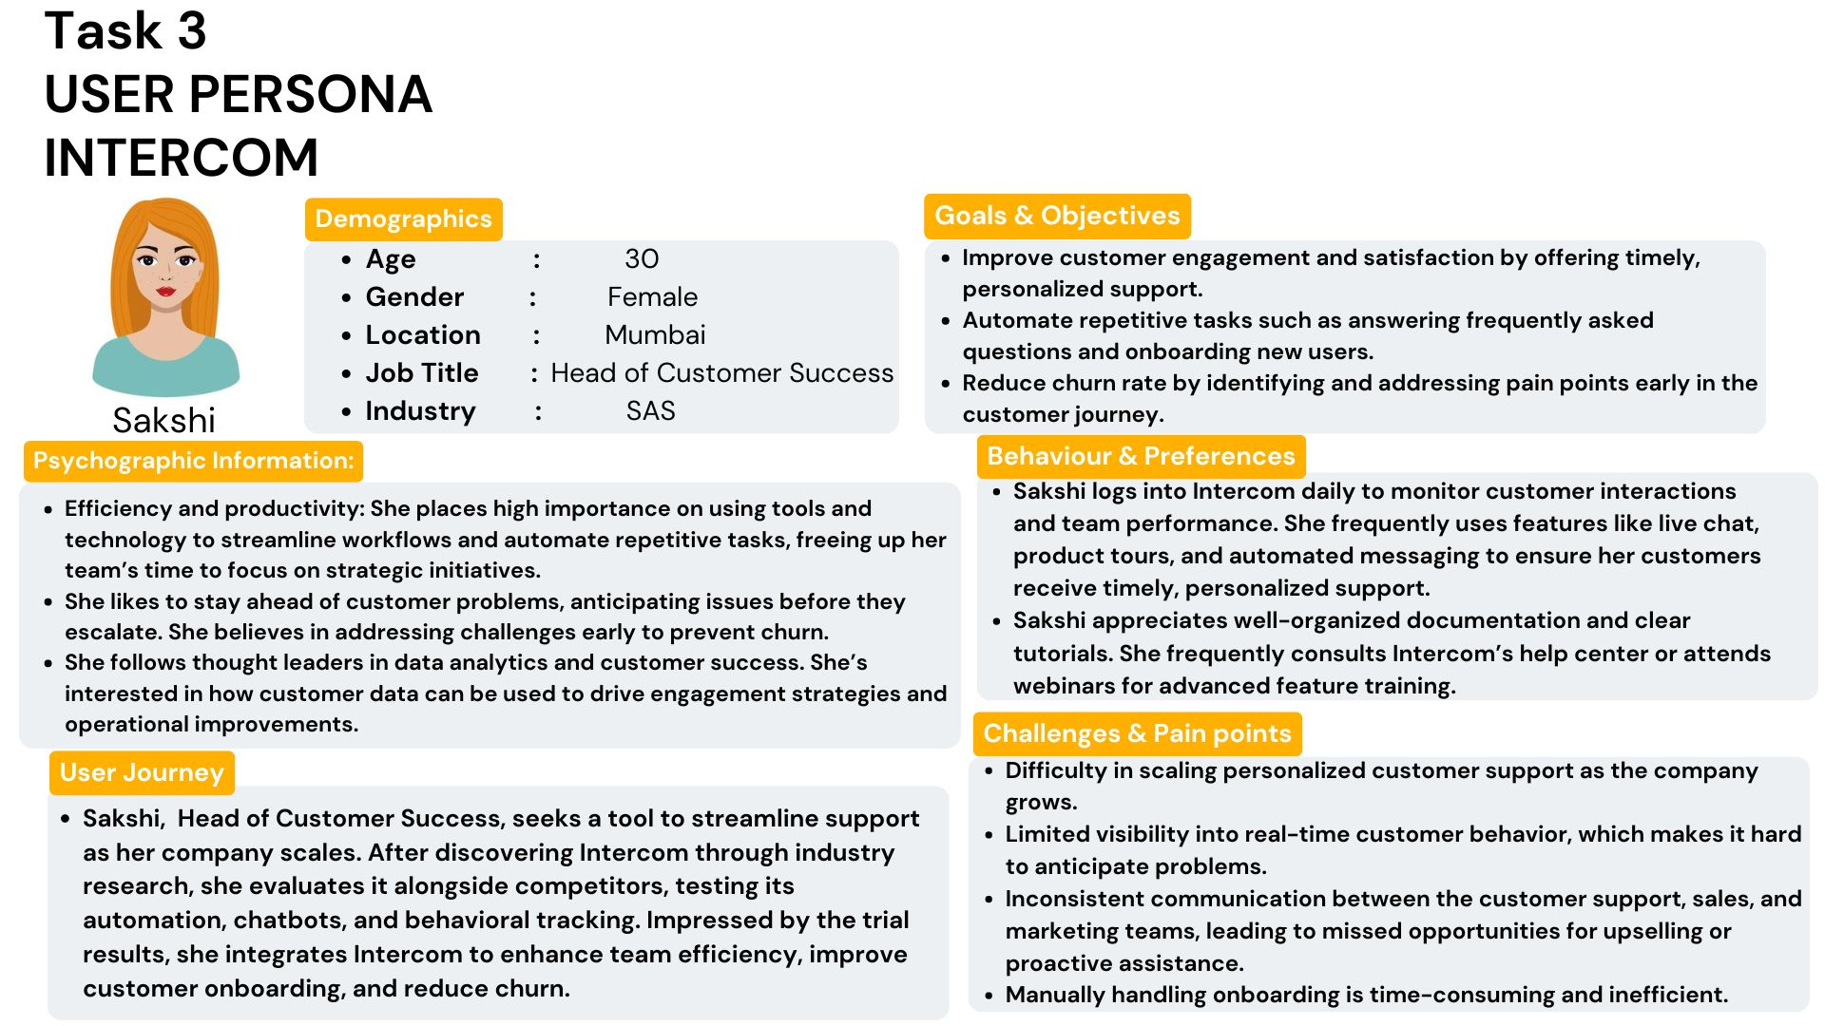

**User Journey Map for Intercom:**

1. **Awareness & Consideration**
   * **Goal**: Find a customer communication platform.
   * **Actions**: Research options, compare features.
   * **Pain Points**: Overwhelmed by choices, unclear pricing.
2. **Onboarding & Setup**
   * **Goal**: Quickly set up and integrate Intercom.
   * **Actions**: Sign up, install widgets, follow tutorials.
   * **Pain Points**: Confusing setup, integration issues.
3. **Daily Use**
   * **Goal**: Manage customer support and automate tasks.
   * **Actions**: Respond to tickets, use automation tools.
   * **Pain Points**: Navigation issues, complex automation setup.
4. **Optimization**
   * **Goal**: Customize workflows, analyze data.
   * **Actions**: Refine automations, use advanced features.
   * **Pain Points**: Complexity in optimizing and setting up advanced tools.
5. **Support & Feedback**
   * **Goal**: Get help and give feedback.
   * **Actions**: Contact support, submit feature requests.
   * **Pain Points**: Slow support responses, limited feedback follow-up.
6. **Retention & Renewal**
   * **Goal**: Evaluate whether to continue using Intercom.
   * **Actions**: Review platform performance, assess pricing.
   * **Pain Points**: Pricing concerns, missing features.